**Flowaction Types:**

**2 Types:**

**1: Connector Flowaction**

**2: Local Flowaction/Local Action**

**Connector Flowaction: Process Rule which allows us to perform actions on the assignment & Moves the WO from current assignment to Next Assignment.**

**Local Action: It is also a Process Rule which allows to Perform action on the Assignment, but still WO will be there on the same assignment.**

**Ex: Model Dialog, Overlay**

**- For Assignment we can add Multiple Connector Flowactions & Multiple Local Actions.**

**How to Create Local Action:**

**Process-> Flowaction**

**Go to Action tab: Scroll Down**

**Indicator: select Local Action**

**Where to Call Local Actions in Flow Rule:**

**1- From Assignment Shape ( Advanced settings-> Local Action)**

**2- Flow Rule ( Go to Design Tab- Flow Wide Local Actions)**

**-------**

**3- UI Controls in Section**

**If Local Action is Called at Assignment Shape: It is available only for that Assignment**

**If Local Action is called at Design tab of Flow: Available on all Assignments**

**After Mapping your Local Action. Local Action will be accessible from Action Dropdown**

**If Local Action is Called at Assignment Shape, it will be available under action dropdown when the WO is on the same assignment.**

**If Local Action is Called under Design tab, it will be available under action dropdown at all assignments**

**Req: Modify Existing behaviour of Application as Described below**

**1- Users Should be able to update Agency Details when the WO is at Address Assignment.**

**2- Users Should be able to update Policy details from any assignment in the flow**

**Create Local Actions:**

**Create Agency Local Action:**

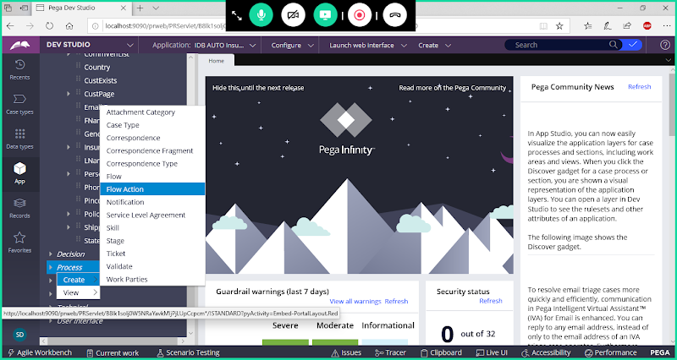

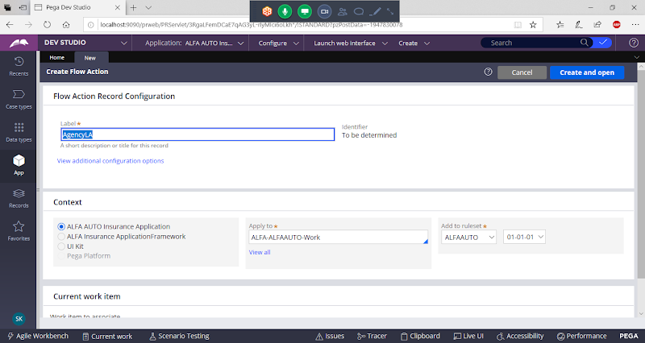

**Open**

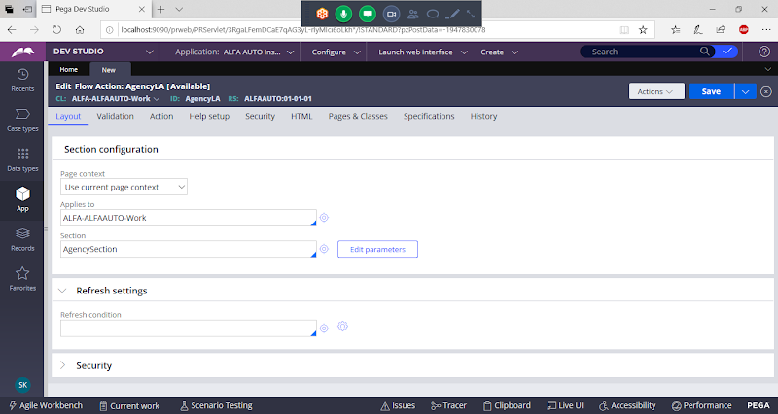

**Go to Action Tab:**

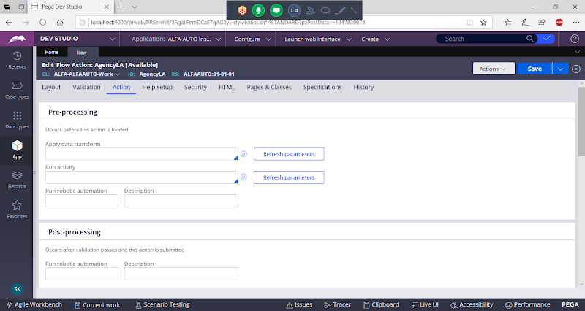

**Scroll Down**

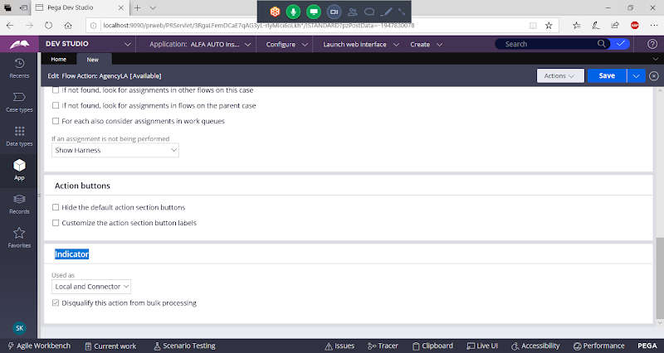

**Under Indicator Select : Local Action**

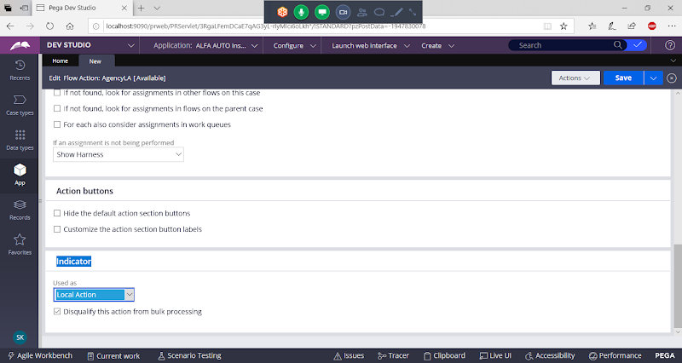

**Save Local Action**

**===**

**Create Policy Local Action:**



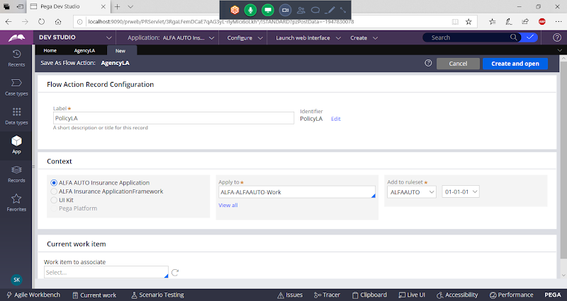

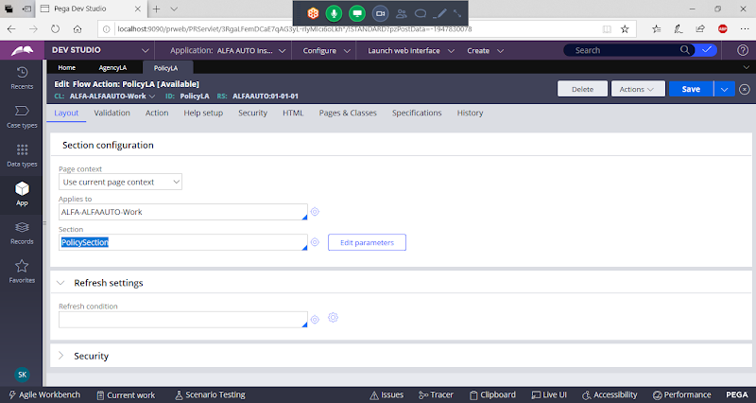

**Go to Action Tab & select LocalAction:**

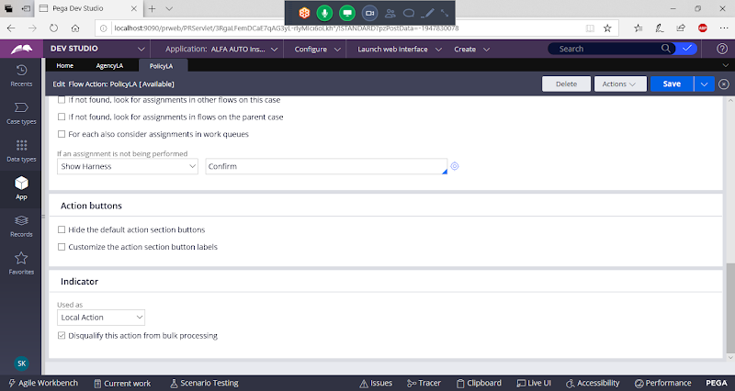

**Save Local Action**

**Now Open Insurance Flow:**

**Call Agency Local Action under Address Details Assignment:**

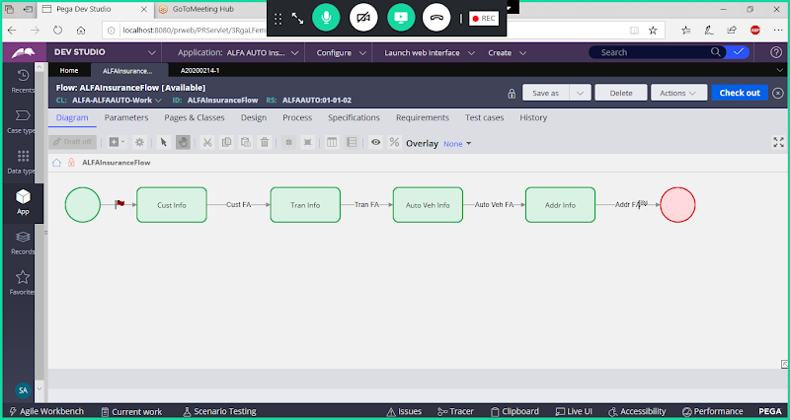

**Double Click on Address Assignment:**

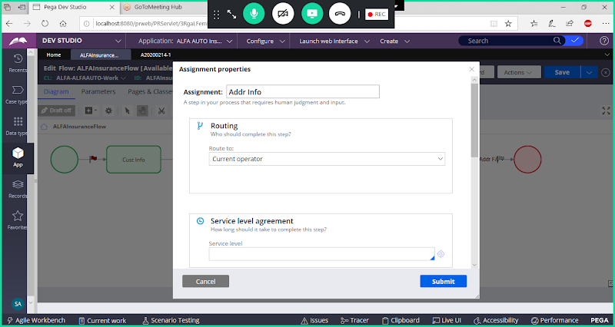

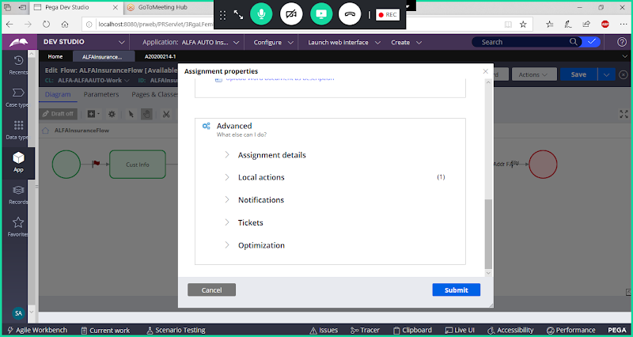

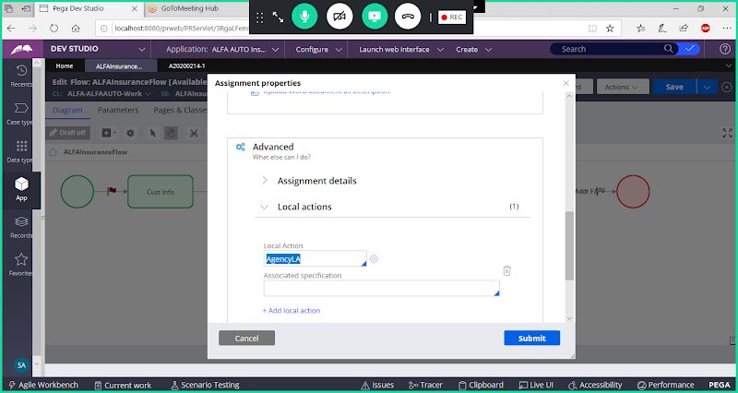

**Submit**

**Now Policy Local Action Call under Design Tab of flow**

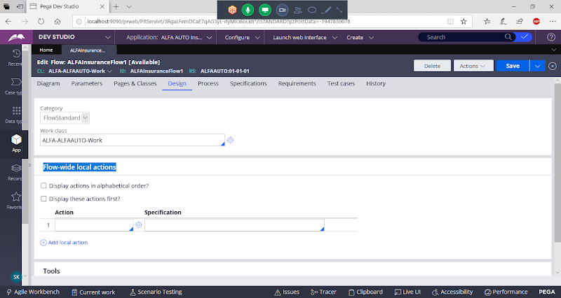

**Add Policy LA**

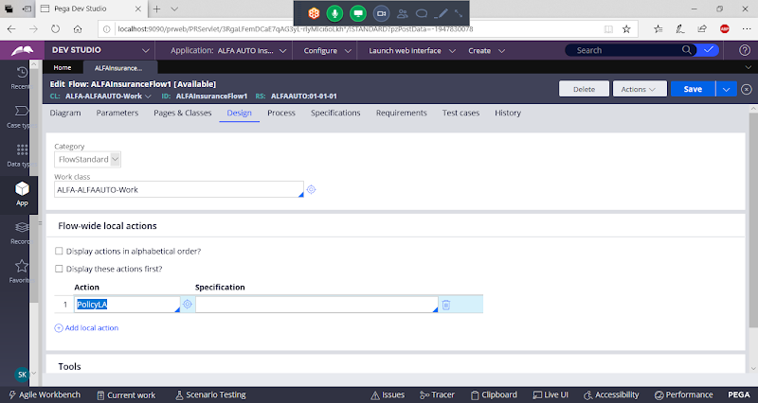

**Save Flow& Check in**

**Run the flow**

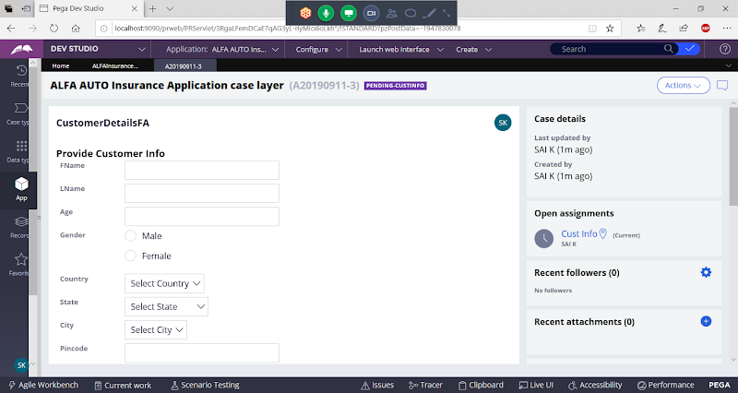

**Now Policy LA we can access at every assignment, Open Policy LA from Action Dropdown:**

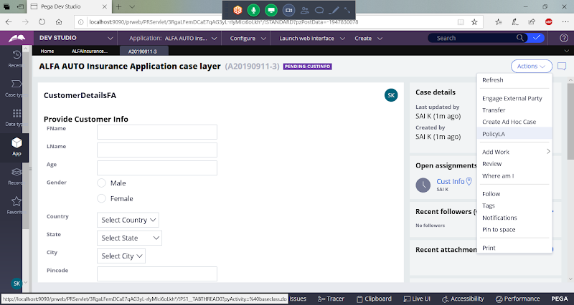

**Open & Submit Data**

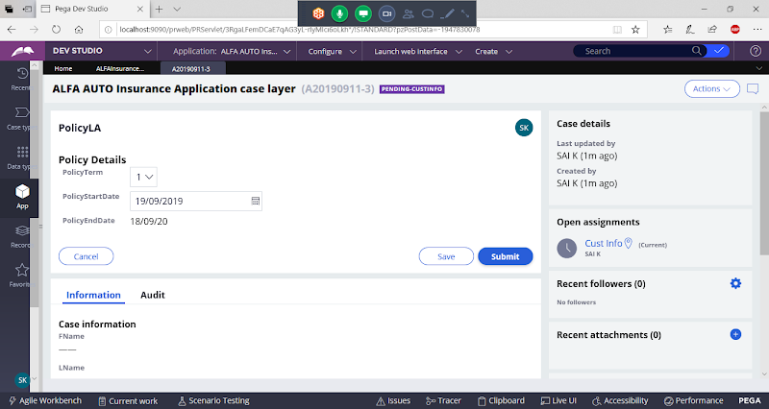

**Click on Submit, the WO will remain on the same page.**

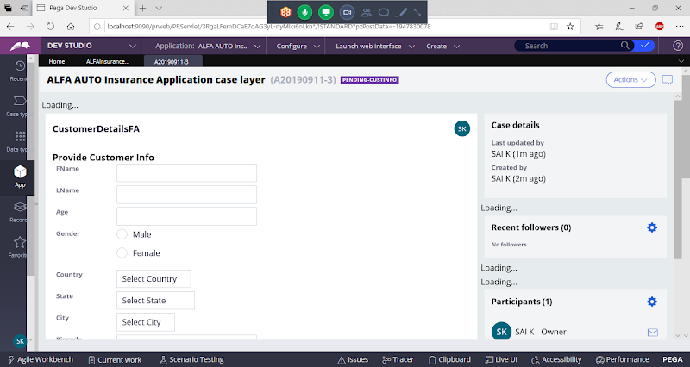

**Now Click on submit**

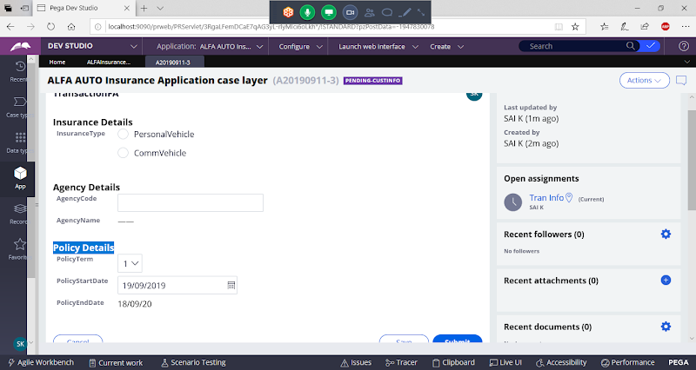

**Submit**

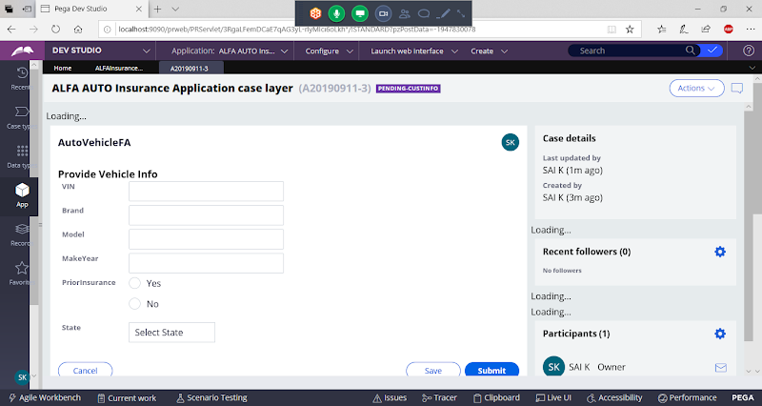

**At Vehicle Assignment We can access only Policy LA.**

**Now Submit**

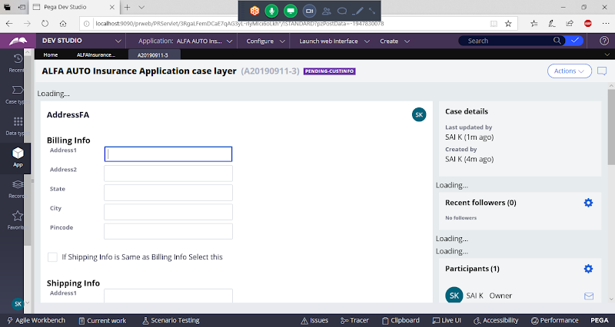

**In Address we can access both Policy LA & Agency LA**

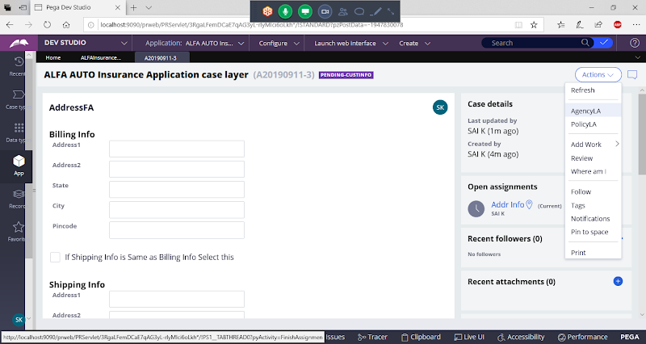

**Open Agency LA**

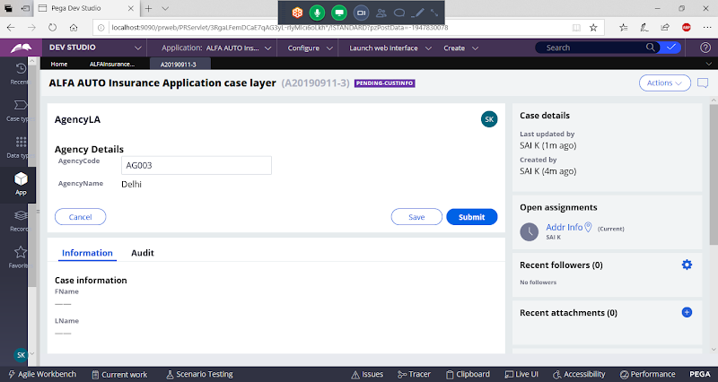

**If we need any changes in Agency details means you can update**

**Submit**

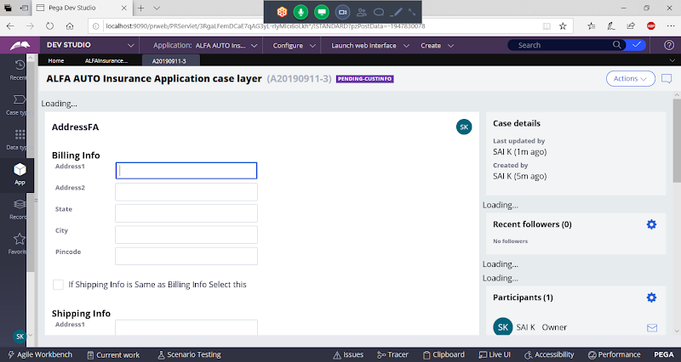

**Finish the WO/Transaction**

**=====**

**Difference B/w Connector Flowaction & Local Action:**

**Connector Flowaction:**

**- Created from Process Category**

**- Connector Flowaction will allow to move the  WO from Current Assignment to Next Assignment**

**- Flowaction we can add in Flow under Assignment Connector**

**- For 1 Assignment we can add Multiple Connector Flowactions ( Not a Best Practice)**

**- Perform Harness is responsible for Loading Connector Flowaction**

**- Connector Flowactions we can call using Actions ( Link, Button, Menus ( Connector Flowaction is not Recommended).**

**LocalAction:**

**- Created from Process Category**

**- When Using Local Action the WO will remain on the Same Assignment**

**- Local action we can add in Flow under Assignment Properties or from Design tab of Flow**

**- For 1 Assignment we can add multiple Local Actions and for one flow we can add multiple flow wide local actions**

**- Perform Harness will Load Local Action.**

**- LocalAction we can call using Controls ( Link, Button, Menus), Local Actions is Preferred Mostly to call from UI Controls**

**Likeli Hood:**

**Likeli hood Value : 100 ( Default)**

**We can add any no of connectors to Assignment.**

**It will execute the connector based on likelihood, if a connector is having highest likelyhood  that connector will get executed. Remaining Pages are available under Action dropdown.**

**If for all the connectors if Likelihood value is same means then it will execute Straight connector added to the assignment/ Based on Alphabetic order it executes.**

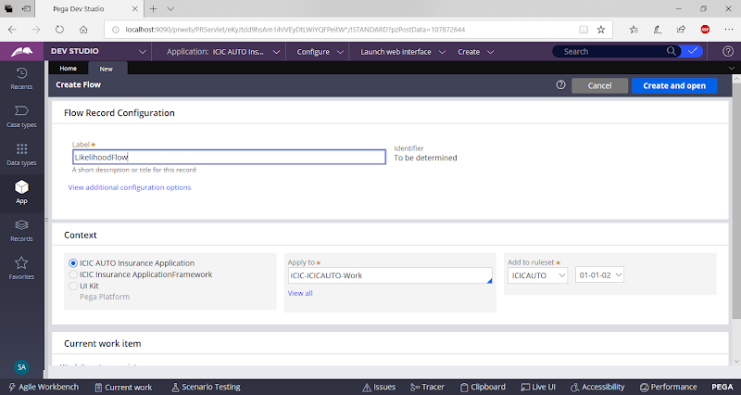

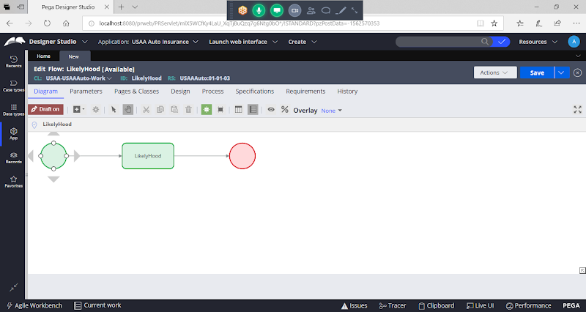

**Double Click on Assignment Connector:**



